REFERENCIAS TRIPLE TRAY
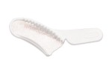
REF. 96285 - 1006283
Wide Body Posterior
48 u.
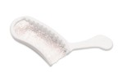
REF. 96339 -1006203
Posterior
48 u.
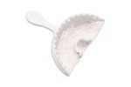
REF. 96108 -1006213
Anterior
35 u.
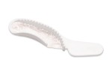
REF. 96109 - 1006223
Quadrant
40 u.
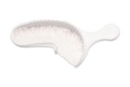
REF. 36753- 1006253
Extended Quadrant
35 u.
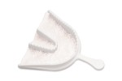
REF. 6528- 1006273
Three-Quarter Arch
35 u.

